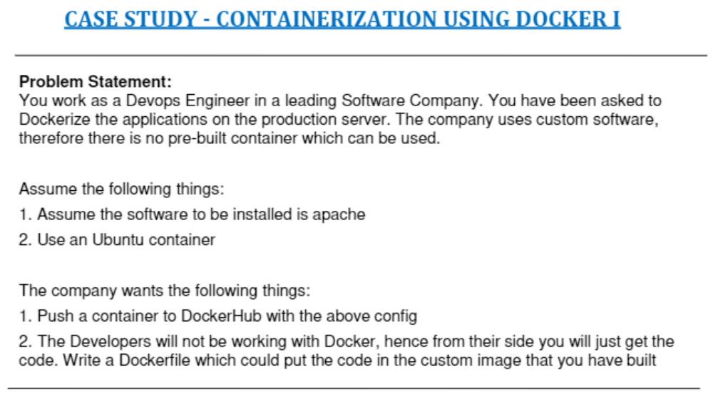
ubuntu@ip-172-31-39-74:~$ ubuntu@ip-172-31-39-74:~$ sudo docker pull ubuntu:16.04
16.04: Pulling from library/ubuntu
Digest: sha256:0f71fa8d4d2d4292c3c617fda2b36f6dabe5c8b6e34c3dc5b0d17d4e704bd39c
Status: Image is up to date for ubuntu:16.04
docker.io/library/ubuntu:16.04
ubuntu@ip-172-31-39-74:~$ sudo docker run -it ubuntu:16.04
root@0ca08a2c0ebd:/#
root@0ca08a2c0ebd:/# ls
bin boot dev etc home lib lib64 media mnt opt proc root run sbin srv sys tmp usr var
root@0ca08a2c0ebd:/# apt-get update
Get:1 http://security.ubuntu.com/ubuntu xenial-security InRelease [109 kB]
Get:2 http://archive.ubuntu.com/ubuntu xenial InRelease [247 kB]
Get:3 http://security.ubuntu.com/ubuntu xenial-security/main amd64 Packages [2051 kB]
Get:4 http://security.ubuntu.com/ubuntu xenial-security/restricted amd64 Packages [15.9 kB]
Get:5 http://security.ubuntu.com/ubuntu xenial-security/universe amd64 Packages [984 kB]
Get:6 http://security.ubuntu.com/ubuntu xenial-security/multiverse amd64 Packages [8820 B]
Get:7 http://archive.ubuntu.com/ubuntu xenial-updates InRelease [109 kB]
Get:8 http://archive.ubuntu.com/ubuntu xenial-backports InRelease [107 kB]
Get:9 http://archive.ubuntu.com/ubuntu xenial/main amd64 Packages [1558 kB]
Get:10 http://archive.ubuntu.com/ubuntu xenial/restricted amd64 Packages [14.1 kB]
Get:11 http://archive.ubuntu.com/ubuntu xenial/universe amd64 Packages [9827 kB]
Get:12 http://archive.ubuntu.com/ubuntu xenial/multiverse amd64 Packages [176 kB]
Get:13 http://archive.ubuntu.com/ubuntu xenial-updates/main amd64 Packages [2560 kB]
Get:14 http://archive.ubuntu.com/ubuntu xenial-updates/restricted amd64 Packages [16.4 kB]
Get:15 http://archive.ubuntu.com/ubuntu xenial-updates/universe amd64 Packages [1544 kB]
Get:16 http://archive.ubuntu.com/ubuntu xenial-updates/multiverse amd64 Packages [26.2 kB]
Get:17 http://archive.ubuntu.com/ubuntu xenial-backports/main amd64 Packages [10.9 kB]
Get:18 http://archive.ubuntu.com/ubuntu xenial-backports/universe amd64 Packages [12.7 kB]
Fetched 19.4 MB in 2s (6690 kB/s)
Reading package lists... Done
root@0ca08a2c0ebd:/# apt-get install apache2
Reading package lists... Done
Building dependency tree
Reading state information... Done
The following additional packages will be installed:
apache2-bin apache2-data apache2-utils file ifupdown iproute2 isc-dhcp-client isc-dhcp-common libapr1 libaprutil1
libaprutil1-dbd-sqlite3 libaprutil1-ldap libasn1-8-heimdal libatm1 libdns-export162 libexpat1 libffi6 libgdbm3
libgmp10 libgnutls30 libgssapi3-heimdal libhcrypto4-heimdal libheimbase1-heimdal libheimntlm0-heimdal libhogweed4
libhx509-5-heimdal libicu55 libidn11 libisc-export160 libkrb5-26-heimdal libldap-2.4-2 liblua5.1-0 libmagic1 libmnl0
libnettle6 libp11-kit0 libperl5.22 libroken18-heimdal libsasl2-2 libsasl2-modules libsasl2-modules-db libsqlite3-0
libssl1.0.0 libtasn1-6 libwind0-heimdal libxml2 libxtables11 mime-support netbase openssl perl perl-modules-5.22
rename sgml-base ssl-cert xml-core
Suggested packages:
www-browser apache2-doc apache2-suexec-pristine | apache2-suexec-custom ufw ppp rdnssd iproute2-doc resolvconf
avahi-autoipd isc-dhcp-client-ddns apparmor gnutls-bin libsasl2-modules-otp libsasl2-modules-ldap
libsasl2-modules-sql libsasl2-modules-gssapi-mit | libsasl2-modules-gssapi-heimdal ca-certificates perl-doc
libterm-readline-gnu-perl | libterm-readline-perl-perl make sgml-base-doc openssl-blacklist debhelper
The following NEW packages will be installed:
apache2 apache2-bin apache2-data apache2-utils file ifupdown iproute2 isc-dhcp-client isc-dhcp-common libapr1
libaprutil1 libaprutil1-dbd-sqlite3 libaprutil1-ldap libasn1-8-heimdal libatm1 libdns-export162 libexpat1 libffi6
libgdbm3 libgmp10 libgnutls30 libgssapi3-heimdal libhcrypto4-heimdal libheimbase1-heimdal libheimntlm0-heimdal
libhogweed4 libhx509-5-heimdal libicu55 libidn11 libisc-export160 libkrb5-26-heimdal libldap-2.4-2 liblua5.1-0
libmagic1 libmnl0 libnettle6 libp11-kit0 libperl5.22 libroken18-heimdal libsasl2-2 libsasl2-modules
libsasl2-modules-db libsqlite3-0 libssl1.0.0 libtasn1-6 libwind0-heimdal libxml2 libxtables11 mime-support netbase
openssl perl perl-modules-5.22 rename sgml-base ssl-cert xml-core
0 upgraded, 57 newly installed, 0 to remove and 0 not upgraded.
Need to get 22.6 MB of archives.
After this operation, 102 MB of additional disk space will be used.
Do you want to continue? [Y/n] Y
Get:1 http://archive.ubuntu.com/ubuntu xenial/main amd64 libatm1 amd64 1:2.5.1-1.5 [24.2 kB]
Get:2 http://archive.ubuntu.com/ubuntu xenial/main amd64 libmnl0 amd64 1.0.3-5 [12.0 kB]
Get:3 http://archive.ubuntu.com/ubuntu xenial/main amd64 libgdbm3 amd64 1.8.3-13.1 [16.9 kB]
Get:4 http://archive.ubuntu.com/ubuntu xenial/main amd64 sgml-base all 1.26+nmu4ubuntu1 [12.5 kB]
Get:5 http://archive.ubuntu.com/ubuntu xenial-updates/main amd64 perl-modules-5.22 all 5.22.1-9ubuntu0.9 [2634 kB]
Get:6 http://archive.ubuntu.com/ubuntu xenial-updates/main amd64 libperl5.22 amd64 5.22.1-9ubuntu0.9 [3360 kB]
Get:7 http://archive.ubuntu.com/ubuntu xenial-updates/main amd64 perl amd64 5.22.1-9ubuntu0.9 [237 kB]
Get:8 http://archive.ubuntu.com/ubuntu xenial/main amd64 mime-support all 3.59ubuntu1 [31.0 kB]
Get:9 http://archive.ubuntu.com/ubuntu xenial/main amd64 libapr1 amd64 1.5.2-3 [86.0 kB]
Get:10 http://archive.ubuntu.com/ubuntu xenial-updates/main amd64 libexpat1 amd64 2.1.0-7ubuntu0.16.04.5 [71.5 kB]
Get:11 http://archive.ubuntu.com/ubuntu xenial-updates/main amd64 libssl1.0.0 amd64 1.0.2g-1ubuntu4.20 [1083 kB]
Get:12 http://archive.ubuntu.com/ubuntu xenial/main amd64 libaprutil1 amd64 1.5.4-1build1 [77.1 kB]
Get:13 http://archive.ubuntu.com/ubuntu xenial-updates/main amd64 libsqlite3-0 amd64 3.11.0-1ubuntu1.5 [398 kB]
Get:14 http://archive.ubuntu.com/ubuntu xenial/main amd64 libaprutil1-dbd-sqlite3 amd64 1.5.4-1build1 [10.6 kB]
Get:15 http://archive.ubuntu.com/ubuntu xenial/main amd64 libgmp10 amd64 2:6.1.0+dfsg-2 [240 kB]
Get:16 http://archive.ubuntu.com/ubuntu xenial-updates/main amd64 libnettle6 amd64 3.2-1ubuntu0.16.04.2 [93.7 kB]
Get:17 http://archive.ubuntu.com/ubuntu xenial-updates/main amd64 libhogweed4 amd64 3.2-1ubuntu0.16.04.2 [136 kB]
Get:18 http://archive.ubuntu.com/ubuntu xenial-updates/main amd64 libidn11 amd64 1.32-3ubuntu1.2 [46.5 kB]
Get:19 http://archive.ubuntu.com/ubuntu xenial/main amd64 libffi6 amd64 3.2.1-4 [17.8 kB]
Get:20 http://archive.ubuntu.com/ubuntu xenial-updates/main amd64 libp11-kit0 amd64 0.23.2-5~ubuntu16.04.2 [107 kB]
Get:21 http://archive.ubuntu.com/ubuntu xenial-updates/main amd64 libtasn1-6 amd64 4.7-3ubuntu0.16.04.3 [43.5 kB]
Get:22 http://archive.ubuntu.com/ubuntu xenial-updates/main amd64 libgnutls30 amd64 3.4.10-4ubuntu1.9 [548 kB]
Get:23 http://archive.ubuntu.com/ubuntu xenial-updates/main amd64 libroken18-heimdal amd64 1.7~git20150920+dfsg-4ubuntu1.16.04.1 [41.4 kB]
Get:24 http://archive.ubuntu.com/ubuntu xenial-updates/main amd64 libasn1-8-heimdal amd64 1.7~git20150920+dfsg-4ubuntu1.16.04.1 [174 kB]
Get:25 http://archive.ubuntu.com/ubuntu xenial-updates/main amd64 libhcrypto4-heimdal amd64 1.7~git20150920+dfsg-4ubuntu1.16.04.1 [85.0 kB]
Get:26 http://archive.ubuntu.com/ubuntu xenial-updates/main amd64 libheimbase1-heimdal amd64 1.7~git20150920+dfsg-4ubuntu1.16.04.1 [29.3 kB]
Get:27 http://archive.ubuntu.com/ubuntu xenial-updates/main amd64 libwind0-heimdal amd64 1.7~git20150920+dfsg-4ubuntu1.16.04.1 [47.8 kB]
Get:28 http://archive.ubuntu.com/ubuntu xenial-updates/main amd64 libhx509-5-heimdal amd64 1.7~git20150920+dfsg-4ubuntu1.16.04.1 [107 kB]
Get:29 http://archive.ubuntu.com/ubuntu xenial-updates/main amd64 libkrb5-26-heimdal amd64 1.7~git20150920+dfsg-4ubuntu1.16.04.1 [202 kB]
Get:30 http://archive.ubuntu.com/ubuntu xenial-updates/main amd64 libheimntlm0-heimdal amd64 1.7~git20150920+dfsg-4ubuntu1.16.04.1 [15.1 kB]
Get:31 http://archive.ubuntu.com/ubuntu xenial-updates/main amd64 libgssapi3-heimdal amd64 1.7~git20150920+dfsg-4ubuntu1.16.04.1 [96.1 kB]
Get:32 http://archive.ubuntu.com/ubuntu xenial-updates/main amd64 libsasl2-modules-db amd64 2.1.26.dfsg1-14ubuntu0.2 [14.5 kB]
Get:33 http://archive.ubuntu.com/ubuntu xenial-updates/main amd64 libsasl2-2 amd64 2.1.26.dfsg1-14ubuntu0.2 [48.7 kB]
Get:34 http://archive.ubuntu.com/ubuntu xenial-updates/main amd64 libldap-2.4-2 amd64 2.4.42+dfsg-2ubuntu3.13 [159 kB]
Get:35 http://archive.ubuntu.com/ubuntu xenial/main amd64 libaprutil1-ldap amd64 1.5.4-1build1 [8720 B]
Get:36 http://archive.ubuntu.com/ubuntu xenial/main amd64 liblua5.1-0 amd64 5.1.5-8ubuntu1 [102 kB]
Get:37 http://archive.ubuntu.com/ubuntu xenial-updates/main amd64 libicu55 amd64 55.1-7ubuntu0.5 [7650 kB]
Get:38 http://archive.ubuntu.com/ubuntu xenial-updates/main amd64 libxml2 amd64 2.9.3+dfsg1-1ubuntu0.7 [698 kB]
Get:39 http://archive.ubuntu.com/ubuntu xenial-updates/main amd64 apache2-bin amd64 2.4.18-2ubuntu3.17 [927 kB]
Get:40 http://archive.ubuntu.com/ubuntu xenial-updates/main amd64 apache2-utils amd64 2.4.18-2ubuntu3.17 [81.9 kB]
Get:41 http://archive.ubuntu.com/ubuntu xenial-updates/main amd64 apache2-data all 2.4.18-2ubuntu3.17 [162 kB]
Get:42 http://archive.ubuntu.com/ubuntu xenial-updates/main amd64 apache2 amd64 2.4.18-2ubuntu3.17 [86.8 kB]
Get:43 http://archive.ubuntu.com/ubuntu xenial-updates/main amd64 libmagic1 amd64 1:5.25-2ubuntu1.4 [216 kB]
Get:44 http://archive.ubuntu.com/ubuntu xenial-updates/main amd64 file amd64 1:5.25-2ubuntu1.4 [21.2 kB]
Get:45 http://archive.ubuntu.com/ubuntu xenial-updates/main amd64 iproute2 amd64 4.3.0-1ubuntu3.16.04.5 [523 kB]
Get:46 http://archive.ubuntu.com/ubuntu xenial-updates/main amd64 ifupdown amd64 0.8.10ubuntu1.4 [54.9 kB]
Get:47 http://archive.ubuntu.com/ubuntu xenial-updates/main amd64 libisc-export160 amd64 1:9.10.3.dfsg.P4-8ubuntu1.19 [153 kB]
Get:48 http://archive.ubuntu.com/ubuntu xenial-updates/main amd64 libdns-export162 amd64 1:9.10.3.dfsg.P4-8ubuntu1.19 [665 kB]
Get:49 http://archive.ubuntu.com/ubuntu xenial-updates/main amd64 isc-dhcp-client amd64 4.3.3-5ubuntu12.10 [224 kB]
Get:50 http://archive.ubuntu.com/ubuntu xenial-updates/main amd64 isc-dhcp-common amd64 4.3.3-5ubuntu12.10 [105 kB]
Get:51 http://archive.ubuntu.com/ubuntu xenial/main amd64 libxtables11 amd64 1.6.0-2ubuntu3 [27.2 kB]
Get:52 http://archive.ubuntu.com/ubuntu xenial/main amd64 netbase all 5.3 [12.9 kB]
Get:53 http://archive.ubuntu.com/ubuntu xenial-updates/main amd64 libsasl2-modules amd64 2.1.26.dfsg1-14ubuntu0.2 [47.7 kB]
Get:54 http://archive.ubuntu.com/ubuntu xenial-updates/main amd64 openssl amd64 1.0.2g-1ubuntu4.20 [492 kB]
Get:55 http://archive.ubuntu.com/ubuntu xenial/main amd64 xml-core all 0.13+nmu2 [23.3 kB]
Get:56 http://archive.ubuntu.com/ubuntu xenial/main amd64 rename all 0.20-4 [12.0 kB]
Get:57 http://archive.ubuntu.com/ubuntu xenial/main amd64 ssl-cert all 1.0.37 [16.9 kB]
Fetched 22.6 MB in 2s (9819 kB/s)
debconf: delaying package configuration, since apt-utils is not installed
Selecting previously unselected package libatm1:amd64.
(Reading database ... 4785 files and directories currently installed.)
Preparing to unpack .../libatm1_1%3a2.5.1-1.5_amd64.deb ...
Unpacking libatm1:amd64 (1:2.5.1-1.5) ...
Selecting previously unselected package libmnl0:amd64.
Preparing to unpack .../libmnl0_1.0.3-5_amd64.deb ...
Unpacking libmnl0:amd64 (1.0.3-5) ...
Selecting previously unselected package libgdbm3:amd64.
Preparing to unpack .../libgdbm3_1.8.3-13.1_amd64.deb ...
Unpacking libgdbm3:amd64 (1.8.3-13.1) ...
Selecting previously unselected package sgml-base.
Preparing to unpack .../sgml-base_1.26+nmu4ubuntu1_all.deb ...
Unpacking sgml-base (1.26+nmu4ubuntu1) ...
Selecting previously unselected package perl-modules-5.22.
Preparing to unpack .../perl-modules-5.22_5.22.1-9ubuntu0.9_all.deb ...
Unpacking perl-modules-5.22 (5.22.1-9ubuntu0.9) ...
Selecting previously unselected package libperl5.22:amd64.
Preparing to unpack .../libperl5.22_5.22.1-9ubuntu0.9_amd64.deb ...
Unpacking libperl5.22:amd64 (5.22.1-9ubuntu0.9) ...
Selecting previously unselected package perl.
Preparing to unpack .../perl_5.22.1-9ubuntu0.9_amd64.deb ...
Unpacking perl (5.22.1-9ubuntu0.9) ...
Selecting previously unselected package mime-support.
Preparing to unpack .../mime-support_3.59ubuntu1_all.deb ...
Unpacking mime-support (3.59ubuntu1) ...
Selecting previously unselected package libapr1:amd64.
Preparing to unpack .../libapr1_1.5.2-3_amd64.deb ...
Unpacking libapr1:amd64 (1.5.2-3) ...
Selecting previously unselected package libexpat1:amd64.
Preparing to unpack .../libexpat1_2.1.0-7ubuntu0.16.04.5_amd64.deb ...
Unpacking libexpat1:amd64 (2.1.0-7ubuntu0.16.04.5) ...
Selecting previously unselected package libssl1.0.0:amd64.
Preparing to unpack .../libssl1.0.0_1.0.2g-1ubuntu4.20_amd64.deb ...
Unpacking libssl1.0.0:amd64 (1.0.2g-1ubuntu4.20) ...
Selecting previously unselected package libaprutil1:amd64.
Preparing to unpack .../libaprutil1_1.5.4-1build1_amd64.deb ...
Unpacking libaprutil1:amd64 (1.5.4-1build1) ...
Selecting previously unselected package libsqlite3-0:amd64.
Preparing to unpack .../libsqlite3-0_3.11.0-1ubuntu1.5_amd64.deb ...
Unpacking libsqlite3-0:amd64 (3.11.0-1ubuntu1.5) ...
Selecting previously unselected package libaprutil1-dbd-sqlite3:amd64.
Preparing to unpack .../libaprutil1-dbd-sqlite3_1.5.4-1build1_amd64.deb ...
Unpacking libaprutil1-dbd-sqlite3:amd64 (1.5.4-1build1) ...
Selecting previously unselected package libgmp10:amd64.
Preparing to unpack .../libgmp10_2%3a6.1.0+dfsg-2_amd64.deb ...
Unpacking libgmp10:amd64 (2:6.1.0+dfsg-2) ...
Selecting previously unselected package libnettle6:amd64.
Preparing to unpack .../libnettle6_3.2-1ubuntu0.16.04.2_amd64.deb ...
Unpacking libnettle6:amd64 (3.2-1ubuntu0.16.04.2) ...
Selecting previously unselected package libhogweed4:amd64.
Preparing to unpack .../libhogweed4_3.2-1ubuntu0.16.04.2_amd64.deb ...
Unpacking libhogweed4:amd64 (3.2-1ubuntu0.16.04.2) ...
Selecting previously unselected package libidn11:amd64.
Preparing to unpack .../libidn11_1.32-3ubuntu1.2_amd64.deb ...
Unpacking libidn11:amd64 (1.32-3ubuntu1.2) ...
Selecting previously unselected package libffi6:amd64.
Preparing to unpack .../libffi6_3.2.1-4_amd64.deb ...
Unpacking libffi6:amd64 (3.2.1-4) ...
Selecting previously unselected package libp11-kit0:amd64.
Preparing to unpack .../libp11-kit0_0.23.2-5~ubuntu16.04.2_amd64.deb ...
Unpacking libp11-kit0:amd64 (0.23.2-5~ubuntu16.04.2) ...
Selecting previously unselected package libtasn1-6:amd64.
Preparing to unpack .../libtasn1-6_4.7-3ubuntu0.16.04.3_amd64.deb ...
Unpacking libtasn1-6:amd64 (4.7-3ubuntu0.16.04.3) ...
Selecting previously unselected package libgnutls30:amd64.
Preparing to unpack .../libgnutls30_3.4.10-4ubuntu1.9_amd64.deb ...
Unpacking libgnutls30:amd64 (3.4.10-4ubuntu1.9) ...
Selecting previously unselected package libroken18-heimdal:amd64.
Preparing to unpack .../libroken18-heimdal_1.7~git20150920+dfsg-4ubuntu1.16.04.1_amd64.deb ...
Unpacking libroken18-heimdal:amd64 (1.7~git20150920+dfsg-4ubuntu1.16.04.1) ...
Selecting previously unselected package libasn1-8-heimdal:amd64.
Preparing to unpack .../libasn1-8-heimdal_1.7~git20150920+dfsg-4ubuntu1.16.04.1_amd64.deb ...
Unpacking libasn1-8-heimdal:amd64 (1.7~git20150920+dfsg-4ubuntu1.16.04.1) ...
Selecting previously unselected package libhcrypto4-heimdal:amd64.
Preparing to unpack .../libhcrypto4-heimdal_1.7~git20150920+dfsg-4ubuntu1.16.04.1_amd64.deb ...
Unpacking libhcrypto4-heimdal:amd64 (1.7~git20150920+dfsg-4ubuntu1.16.04.1) ...
Selecting previously unselected package libheimbase1-heimdal:amd64.
Preparing to unpack .../libheimbase1-heimdal_1.7~git20150920+dfsg-4ubuntu1.16.04.1_amd64.deb ...
Unpacking libheimbase1-heimdal:amd64 (1.7~git20150920+dfsg-4ubuntu1.16.04.1) ...
Selecting previously unselected package libwind0-heimdal:amd64.
Preparing to unpack .../libwind0-heimdal_1.7~git20150920+dfsg-4ubuntu1.16.04.1_amd64.deb ...
Unpacking libwind0-heimdal:amd64 (1.7~git20150920+dfsg-4ubuntu1.16.04.1) ...
Selecting previously unselected package libhx509-5-heimdal:amd64.
Preparing to unpack .../libhx509-5-heimdal_1.7~git20150920+dfsg-4ubuntu1.16.04.1_amd64.deb ...
Unpacking libhx509-5-heimdal:amd64 (1.7~git20150920+dfsg-4ubuntu1.16.04.1) ...
Selecting previously unselected package libkrb5-26-heimdal:amd64.
Preparing to unpack .../libkrb5-26-heimdal_1.7~git20150920+dfsg-4ubuntu1.16.04.1_amd64.deb ...
Unpacking libkrb5-26-heimdal:amd64 (1.7~git20150920+dfsg-4ubuntu1.16.04.1) ...
Selecting previously unselected package libheimntlm0-heimdal:amd64.
Preparing to unpack .../libheimntlm0-heimdal_1.7~git20150920+dfsg-4ubuntu1.16.04.1_amd64.deb ...
Unpacking libheimntlm0-heimdal:amd64 (1.7~git20150920+dfsg-4ubuntu1.16.04.1) ...
Selecting previously unselected package libgssapi3-heimdal:amd64.
Preparing to unpack .../libgssapi3-heimdal_1.7~git20150920+dfsg-4ubuntu1.16.04.1_amd64.deb ...
Unpacking libgssapi3-heimdal:amd64 (1.7~git20150920+dfsg-4ubuntu1.16.04.1) ...
Selecting previously unselected package libsasl2-modules-db:amd64.
Preparing to unpack .../libsasl2-modules-db_2.1.26.dfsg1-14ubuntu0.2_amd64.deb ...
Unpacking libsasl2-modules-db:amd64 (2.1.26.dfsg1-14ubuntu0.2) ...
Selecting previously unselected package libsasl2-2:amd64.
Preparing to unpack .../libsasl2-2_2.1.26.dfsg1-14ubuntu0.2_amd64.deb ...
Unpacking libsasl2-2:amd64 (2.1.26.dfsg1-14ubuntu0.2) ...
Selecting previously unselected package libldap-2.4-2:amd64.
Preparing to unpack .../libldap-2.4-2_2.4.42+dfsg-2ubuntu3.13_amd64.deb ...
Unpacking libldap-2.4-2:amd64 (2.4.42+dfsg-2ubuntu3.13) ...
Selecting previously unselected package libaprutil1-ldap:amd64.
Preparing to unpack .../libaprutil1-ldap_1.5.4-1build1_amd64.deb ...
Unpacking libaprutil1-ldap:amd64 (1.5.4-1build1) ...
Selecting previously unselected package liblua5.1-0:amd64.
Preparing to unpack .../liblua5.1-0_5.1.5-8ubuntu1_amd64.deb ...
Unpacking liblua5.1-0:amd64 (5.1.5-8ubuntu1) ...
Selecting previously unselected package libicu55:amd64.
Preparing to unpack .../libicu55_55.1-7ubuntu0.5_amd64.deb ...
Unpacking libicu55:amd64 (55.1-7ubuntu0.5) ...
Selecting previously unselected package libxml2:amd64.
Preparing to unpack .../libxml2_2.9.3+dfsg1-1ubuntu0.7_amd64.deb ...
Unpacking libxml2:amd64 (2.9.3+dfsg1-1ubuntu0.7) ...
Selecting previously unselected package apache2-bin.
Preparing to unpack .../apache2-bin_2.4.18-2ubuntu3.17_amd64.deb ...
Unpacking apache2-bin (2.4.18-2ubuntu3.17) ...
Selecting previously unselected package apache2-utils.
Preparing to unpack .../apache2-utils_2.4.18-2ubuntu3.17_amd64.deb ...
Unpacking apache2-utils (2.4.18-2ubuntu3.17) ...
Selecting previously unselected package apache2-data.
Preparing to unpack .../apache2-data_2.4.18-2ubuntu3.17_all.deb ...
Unpacking apache2-data (2.4.18-2ubuntu3.17) ...
Selecting previously unselected package apache2.
Preparing to unpack .../apache2_2.4.18-2ubuntu3.17_amd64.deb ...
Unpacking apache2 (2.4.18-2ubuntu3.17) ...
Selecting previously unselected package libmagic1:amd64.
Preparing to unpack .../libmagic1_1%3a5.25-2ubuntu1.4_amd64.deb ...
Unpacking libmagic1:amd64 (1:5.25-2ubuntu1.4) ...
Selecting previously unselected package file.
Preparing to unpack .../file_1%3a5.25-2ubuntu1.4_amd64.deb ...
Unpacking file (1:5.25-2ubuntu1.4) ...
Selecting previously unselected package iproute2.
Preparing to unpack .../iproute2_4.3.0-1ubuntu3.16.04.5_amd64.deb ...
Unpacking iproute2 (4.3.0-1ubuntu3.16.04.5) ...
Selecting previously unselected package ifupdown.
Preparing to unpack .../ifupdown_0.8.10ubuntu1.4_amd64.deb ...
Unpacking ifupdown (0.8.10ubuntu1.4) ...
Selecting previously unselected package libisc-export160.
Preparing to unpack .../libisc-export160_1%3a9.10.3.dfsg.P4-8ubuntu1.19_amd64.deb ...
Unpacking libisc-export160 (1:9.10.3.dfsg.P4-8ubuntu1.19) ...
Selecting previously unselected package libdns-export162.
Preparing to unpack .../libdns-export162_1%3a9.10.3.dfsg.P4-8ubuntu1.19_amd64.deb ...
Unpacking libdns-export162 (1:9.10.3.dfsg.P4-8ubuntu1.19) ...
Selecting previously unselected package isc-dhcp-client.
Preparing to unpack .../isc-dhcp-client_4.3.3-5ubuntu12.10_amd64.deb ...
Unpacking isc-dhcp-client (4.3.3-5ubuntu12.10) ...
Selecting previously unselected package isc-dhcp-common.
Preparing to unpack .../isc-dhcp-common_4.3.3-5ubuntu12.10_amd64.deb ...
Unpacking isc-dhcp-common (4.3.3-5ubuntu12.10) ...
Selecting previously unselected package libxtables11:amd64.
Preparing to unpack .../libxtables11_1.6.0-2ubuntu3_amd64.deb ...
Unpacking libxtables11:amd64 (1.6.0-2ubuntu3) ...
Selecting previously unselected package netbase.
Preparing to unpack .../archives/netbase_5.3_all.deb ...
Unpacking netbase (5.3) ...
Selecting previously unselected package libsasl2-modules:amd64.
Preparing to unpack .../libsasl2-modules_2.1.26.dfsg1-14ubuntu0.2_amd64.deb ...
Unpacking libsasl2-modules:amd64 (2.1.26.dfsg1-14ubuntu0.2) ...
Selecting previously unselected package openssl.
Preparing to unpack .../openssl_1.0.2g-1ubuntu4.20_amd64.deb ...
Unpacking openssl (1.0.2g-1ubuntu4.20) ...
Selecting previously unselected package xml-core.
Preparing to unpack .../xml-core_0.13+nmu2_all.deb ...
Unpacking xml-core (0.13+nmu2) ...
Selecting previously unselected package rename.
Preparing to unpack .../archives/rename_0.20-4_all.deb ...
Unpacking rename (0.20-4) ...
Selecting previously unselected package ssl-cert.
Preparing to unpack .../ssl-cert_1.0.37_all.deb ...
Unpacking ssl-cert (1.0.37) ...
Processing triggers for libc-bin (2.23-0ubuntu11.3) ...
Processing triggers for systemd (229-4ubuntu21.31) ...
Setting up libatm1:amd64 (1:2.5.1-1.5) ...
Setting up libmnl0:amd64 (1.0.3-5) ...
Setting up libgdbm3:amd64 (1.8.3-13.1) ...
Setting up sgml-base (1.26+nmu4ubuntu1) ...
Setting up perl-modules-5.22 (5.22.1-9ubuntu0.9) ...
Setting up libperl5.22:amd64 (5.22.1-9ubuntu0.9) ...
Setting up perl (5.22.1-9ubuntu0.9) ...
update-alternatives: using /usr/bin/prename to provide /usr/bin/rename (rename) in auto mode
Setting up mime-support (3.59ubuntu1) ...
Setting up libapr1:amd64 (1.5.2-3) ...
Setting up libexpat1:amd64 (2.1.0-7ubuntu0.16.04.5) ...
Setting up libssl1.0.0:amd64 (1.0.2g-1ubuntu4.20) ...
debconf: unable to initialize frontend: Dialog
debconf: (No usable dialog-like program is installed, so the dialog based frontend cannot be used. at /usr/share/perl5/Debconf/FrontEnd/Dialog.pm line 76.)
debconf: falling back to frontend: Readline
Setting up libaprutil1:amd64 (1.5.4-1build1) ...
Setting up libsqlite3-0:amd64 (3.11.0-1ubuntu1.5) ...
Setting up libaprutil1-dbd-sqlite3:amd64 (1.5.4-1build1) ...
Setting up libgmp10:amd64 (2:6.1.0+dfsg-2) ...
Setting up libnettle6:amd64 (3.2-1ubuntu0.16.04.2) ...
Setting up libhogweed4:amd64 (3.2-1ubuntu0.16.04.2) ...
Setting up libidn11:amd64 (1.32-3ubuntu1.2) ...
Setting up libffi6:amd64 (3.2.1-4) ...
Setting up libp11-kit0:amd64 (0.23.2-5~ubuntu16.04.2) ...
Setting up libtasn1-6:amd64 (4.7-3ubuntu0.16.04.3) ...
Setting up libgnutls30:amd64 (3.4.10-4ubuntu1.9) ...
Setting up libroken18-heimdal:amd64 (1.7~git20150920+dfsg-4ubuntu1.16.04.1) ...
Setting up libasn1-8-heimdal:amd64 (1.7~git20150920+dfsg-4ubuntu1.16.04.1) ...
Setting up libhcrypto4-heimdal:amd64 (1.7~git20150920+dfsg-4ubuntu1.16.04.1) ...
Setting up libheimbase1-heimdal:amd64 (1.7~git20150920+dfsg-4ubuntu1.16.04.1) ...
Setting up libwind0-heimdal:amd64 (1.7~git20150920+dfsg-4ubuntu1.16.04.1) ...
Setting up libhx509-5-heimdal:amd64 (1.7~git20150920+dfsg-4ubuntu1.16.04.1) ...
Setting up libkrb5-26-heimdal:amd64 (1.7~git20150920+dfsg-4ubuntu1.16.04.1) ...
Setting up libheimntlm0-heimdal:amd64 (1.7~git20150920+dfsg-4ubuntu1.16.04.1) ...
Setting up libgssapi3-heimdal:amd64 (1.7~git20150920+dfsg-4ubuntu1.16.04.1) ...
Setting up libsasl2-modules-db:amd64 (2.1.26.dfsg1-14ubuntu0.2) ...
Setting up libsasl2-2:amd64 (2.1.26.dfsg1-14ubuntu0.2) ...
Setting up libldap-2.4-2:amd64 (2.4.42+dfsg-2ubuntu3.13) ...
Setting up libaprutil1-ldap:amd64 (1.5.4-1build1) ...
Setting up liblua5.1-0:amd64 (5.1.5-8ubuntu1) ...
Setting up libicu55:amd64 (55.1-7ubuntu0.5) ...
Setting up libxml2:amd64 (2.9.3+dfsg1-1ubuntu0.7) ...
Setting up apache2-bin (2.4.18-2ubuntu3.17) ...
Setting up apache2-utils (2.4.18-2ubuntu3.17) ...
Setting up apache2-data (2.4.18-2ubuntu3.17) ...
Setting up apache2 (2.4.18-2ubuntu3.17) ...
Enabling module mpm_event.
Enabling module authz_core.
Enabling module authz_host.
Enabling module authn_core.
Enabling module auth_basic.
Enabling module access_compat.
Enabling module authn_file.
Enabling module authz_user.
Enabling module alias.
Enabling module dir.
Enabling module autoindex.
Enabling module env.
Enabling module mime.
Enabling module negotiation.
Enabling module setenvif.
Enabling module filter.
Enabling module deflate.
Enabling module status.
Enabling conf charset.
Enabling conf localized-error-pages.
Enabling conf other-vhosts-access-log.
Enabling conf security.
Enabling conf serve-cgi-bin.
Enabling site 000-default.
invoke-rc.d: could not determine current runlevel
invoke-rc.d: policy-rc.d denied execution of start.
Setting up libmagic1:amd64 (1:5.25-2ubuntu1.4) ...
Setting up file (1:5.25-2ubuntu1.4) ...
Setting up iproute2 (4.3.0-1ubuntu3.16.04.5) ...
Setting up ifupdown (0.8.10ubuntu1.4) ...
Creating /etc/network/interfaces.
Setting up libisc-export160 (1:9.10.3.dfsg.P4-8ubuntu1.19) ...
Setting up libdns-export162 (1:9.10.3.dfsg.P4-8ubuntu1.19) ...
Setting up isc-dhcp-client (4.3.3-5ubuntu12.10) ...
Setting up isc-dhcp-common (4.3.3-5ubuntu12.10) ...
Setting up libxtables11:amd64 (1.6.0-2ubuntu3) ...
Setting up netbase (5.3) ...
Setting up libsasl2-modules:amd64 (2.1.26.dfsg1-14ubuntu0.2) ...
Setting up openssl (1.0.2g-1ubuntu4.20) ...
Setting up xml-core (0.13+nmu2) ...
Setting up rename (0.20-4) ...
update-alternatives: using /usr/bin/file-rename to provide /usr/bin/rename (rename) in auto mode
Setting up ssl-cert (1.0.37) ...
debconf: unable to initialize frontend: Dialog
debconf: (No usable dialog-like program is installed, so the dialog based frontend cannot be used. at /usr/share/perl5/Debconf/FrontEnd/Dialog.pm line 76.)
debconf: falling back to frontend: Readline
Processing triggers for libc-bin (2.23-0ubuntu11.3) ...
Processing triggers for systemd (229-4ubuntu21.31) ...
Processing triggers for sgml-base (1.26+nmu4ubuntu1) ...
root@0ca08a2c0ebd:/# service apache status
apache: unrecognized service
root@0ca08a2c0ebd:/# service apache2 status
* apache2 is not running
root@0ca08a2c0ebd:/# service apache2 start
* Starting Apache httpd web server apache2 AH00558: apache2: Could not reliably determine the server's fully qualified domain name, using 172.17.0.2. Set the 'ServerName' directive globally to suppress this message
*
root@0ca08a2c0ebd:/# service apache2 status
* apache2 is running
root@0ca08a2c0ebd:/# exit
exit
ubuntu@ip-172-31-39-74:~$ sudo docker commit 0ca08a2c0ebd veerannagatate/ubuntu
sha256:382cc99bc21c27ec5355608a0607d17f90519f436ac23bafd6c4af1bb3e688e9
ubuntu@ip-172-31-39-74:~$ sudo docker push veerannagatate/ubuntu
Using default tag: latest
The push refers to repository [docker.io/veerannagatate/ubuntu]
ec6c34f26c03: Pushed
1251204ef8fc: Pushed
47ef83afae74: Pushed
df54c846128d: Pushed
be96a3f634de: Pushed
latest: digest: sha256:d7572af563accaf527ffaf38273042e4886ed6e294b20924dfbaf614066ecf87 size: 1362
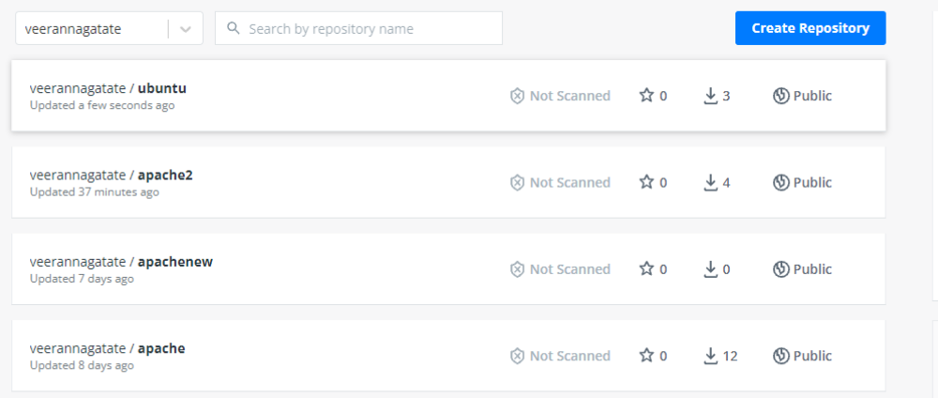
ubuntu@ip-172-31-39-74:~$ vi Dockerfile
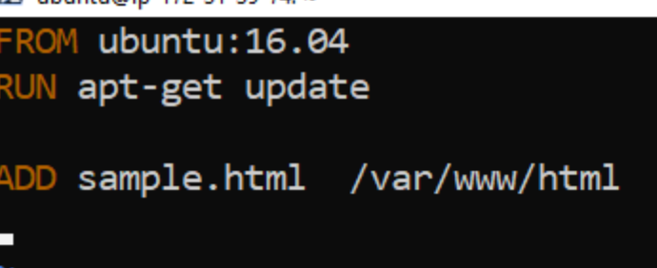
ubuntu@ip-172-31-39-74:~$ vi sample.html
ubuntu@ip-172-31-39-74:~$ ubuntu@ip-172-31-39-74:~$ vi sample.html
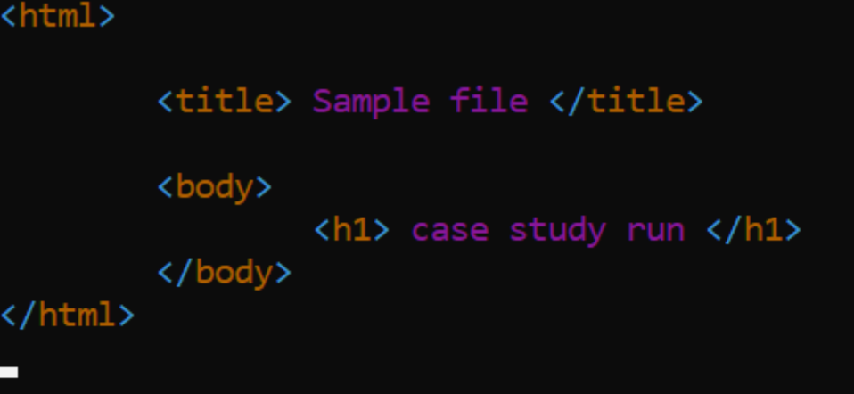
ubuntu@ip-172-31-39-74:~$ sudo docker build . -t docker_cstudy
Sending build context to Docker daemon 31.74kB
Step 1/3 : FROM ubuntu:16.04
---> b6f507652425
Step 2/3 : RUN apt-get update
---> Using cache
---> bf05c22a886d
Step 3/3 : ADD sample.html /var/www/html
---> 0c3384a5b70b
Successfully built 0c3384a5b70b
Successfully tagged docker_cstudy:latest
ubuntu@ip-172-31-39-74:~$

